**FOR IMMEDIATE RELEASE**

October 9, 2025

**Operation Impact 2025: Safety is in MY hands.**

**Ottawa, Ontario** – Tomorrow marks the beginning of *Operation Impact* *2025*, a national public awareness campaign aimed at making Canada's roads the safest in the world. By promoting safe driving behaviours, we hope to help prevent collisions, save lives, and reduce injuries on our roads.

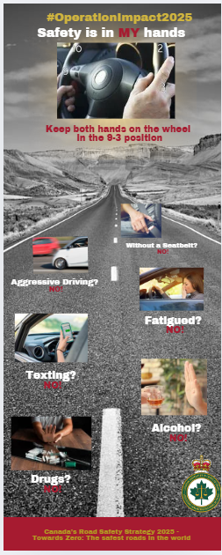From October 10th to 13th, 2025, police across the country will be focused on behaviours that put drivers, passengers, and other road users at risk: impaired driving due to alcohol, drugs, or fatigue, as well as aggressive driving, distracted driving, and driving without a seat belt.

Most collisions are not ‘accidents’, they are generally the direct result of a conscious decision an individual driver has made. This is why the theme of this year’s campaign remains “***Safety is in MY hands***”.

“We are asking Canadians to put safety first. Don’t think you are powerless to reduce the number of injuries and deaths on our roads which are simply too high. Drivers make all the difference,” said Chief Superintendent André Phelps, co-chair of the CACP’s Traffic Safety Committee.

Each year, motor vehicle collisions kill about 2,000 Canadians, seriously injure another 10,000 people and injure about 165,000 citizens in this country.

“If every driver remembers that the decision to be responsible is in their hands when they get behind the wheel, we can collectively achieve our goal. We are quite literally asking Canadians to take a hands-on approach to road safety,” added Inspector Chris Romanchych co-chair of the CACP Traffic Safety Committee.

This campaign is essential to achieve safer streets and highways. It takes place during this long weekend because more people are travelling, and collisions are therefore more frequent.

-30-

**For further information, please contact:**

**Natalie Wright**Communications Advisor | 613.838.8807 | [communications@cacp.ca](mailto:communications@cacp.ca)

*Operation Impact is organized by the Canadian Association of Chiefs of Police, under the leadership of the CACP Traffic Safety Committee, in support of* [*Canada’s Road Safety Strategy 2025*](https://roadsafetystrategy.ca/en/strategy)*.*