**FOR IMMEDIATE RELEASE**

**National Police Week: Committed to Serve Together**

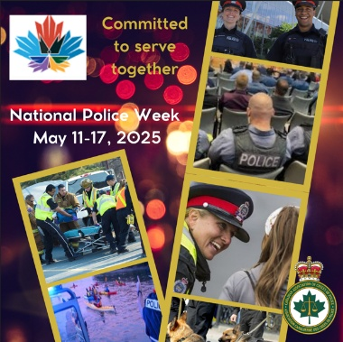**<CITY NAME>,<PROVINCE>, May 11, 2025** – Today marks the beginning of National Police Week – a seven-day public awareness campaign that encourages increased awareness and understanding between police and the communities they serve.

Under the theme **"Committed to Serve Together,"** we acknowledge the crucial partnership between members of a police service, between police services, between the police and other first responders, as well as between the police and the organizations and people in the communities they serve. It is this collaboration that forms the cornerstone of effective crime prevention and public safety initiatives.

"Insert a personalized quote here”, says <Insert name, Insert title>.

This is an opportunity to strengthen the bond between us. By fostering open dialogue, understanding, and mutual respect, we can build safer, more inclusive neighbourhoods where everyone feels valued and protected. By standing united, we demonstrate our unwavering commitment to serve and protect, ensuring a brighter, safer future for generations to come.

This week, and every week, <insert name of police service here> is proud to affirm that it is #CommittedToServeTogether.

-30-

**For further information please contact:**

<**NAME**> | <TITLE> | <PHONE NUMBER> | <EMAIL ADDRESS>