FOR IMMEDIATE RELEASE
National Police Week: Committed to Serve
<CITY NAME>,<PROVINCE>, May 14, 2023 – Today marks the beginning of National Police Week – a seven-day public awareness campaign that encourages increased awareness and understanding between police and the communities they serve.
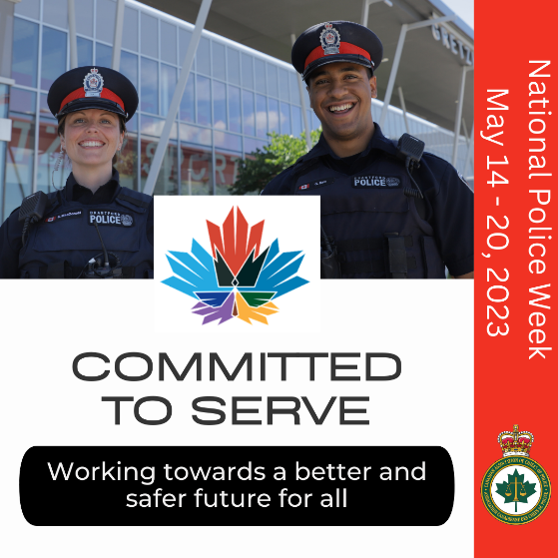
This year, we recognize the oath officers proudly take to be “committed to serve” communities who want and expect the police to keep them safe.
To residents, we are the police. They do not differentiate between patches, names, or police services, but simply want one thing — for us to keep them safe and well. This is the duty and responsibility we proudly assume 24 hours a day, 7 days a week, 365 days a year.
“Insert quote here”, said <insert name of police leader here>, <insert name of police service here>.
Public safety involves a collaborative effort within police agencies, between police services, and between the police, other first responders, social and community services, as well as residents. This week, the <insert name of police service here> renews its oath to be #CommittedToServe the citizens in our region as we work together towards a better and safer future for all.
-30-

For further information please contact:
<NAME> | <TITLE> | <PHONE NUMBER> | <EMAIL ADDRESS>

