FOR IMMEDIATE RELEASE
Canada Road Safety Week 2026
Road Safety — Every Road. Every Day. Everyone.
<CITY NAME>,<PROVINCE>, May 12, 2026 – Today marks the beginning of Canada Road Safety Week, a 7-day national campaign aimed at making Canada's roads the safest in the world. This annual awareness campaign is designed to increase public compliance with safe driving measures to save lives and reduce injuries on Canada’s roads. The focus of this campaign continues to be on the elimination of impaired driving, distracted driving, aggressive driving, and driving without a seatbelt.
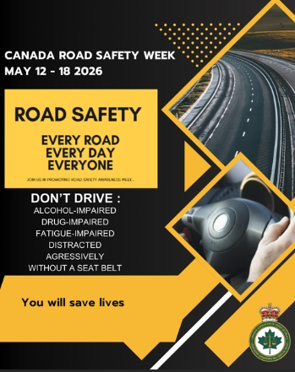
This year’s campaign theme continues to be “Road Safety — Every Road. Every Day. Everyone.”. Let's reaffirm our commitment to ensuring safe journeys for all, not only this week, but always. Remember: Every time you buckle up, obey road safety rules and ensure your mind is clear. You are not just safeguarding yourself and your passengers, but also everyone else with whom you share the road. Let’s make every day a day of conscientious driving.
"Insert a personalized quote here”, says <Insert name, Insert title>.
The <Insert name of police service here> is proud to be participating in this year’s Canada Road Safety Week campaign. While this public safety initiative is part of a national effort to help advance Canada’s Road Safety Strategy 2035 and Beyond to make Canada’s roads the safest in the world, our local efforts aim to make the roads here in <Insert community name here> among the safest in Canada.
Together, let’s strive for safer travels, ensuring that every journey ends with a safe arrival on every road, every day, for everyone.
-30-

For further information please contact:
<NAME>
<TITLE>
<PHONE NUMBER>
<EMAIL ADDRESS>

